BJ to PUM/PR Labs 2-3-4

4.1 t-SNE: t-Distributed Stochastic Neighbor Embedding:
t-SNE (t-Distributed Stochastic Neighbor Embedding), a powerful technique for visualizing high-dimensional data in a lower-dimensional space, particularly useful for clustering analysis.

Visualizing data with many features (dimensions) using traditional methods (think scatter plots) becomes impossible as we run out of spatial axes.
• Distances in High Dimension:
- t-SNE starts by calculating the pairwise similarities between data points in the high-dimensional space. These similarities can be measured using Euclidean distance or cosine similarity.
- importance of Normalization: In many cases, normalization of your data before applying t-SNE is recommended. Normalization ensures that all features are on a similar scale, preventing features with larger ranges from dominating the distance calculations.
- Impact on Similarities: t-SNE relies on calculating pairwise similarities between data points. If features have vastly different scales, Euclidean distances (or other similarity measures) will be heavily influenced by features with larger scales, potentially distorting the underlying relationships in the data.
- Normalization Techniques: Common normalization techniques include:
  - Min-Max Scaling: Scales each feature to a range between 0 and 1.
  - Standard Normalization (Z-score): Standardizes each feature by subtracting the mean and dividing by the standard deviation.
However, there are also situations where normalization might not be necessary:
- Pre-processed Data: If your data has already undergone preprocessing steps that ensure features are on similar scales (e.g., centering), normalization might be less crucial.
- Scale-Invariant Similarities: Some similarity measures used in t-SNE, like cosine similarity, are inherently less sensitive to feature scales.
In summary:
- Generally, normalizing your data before applying t-SNE is a good practice to avoid biases caused by features with different scales.
- However, consider the specific characteristics of your data and the chosen similarity measure to determine if normalization is strictly necessary.

1. Initializing the Low-Dimensional Map:
- We start by creating a random low-dimensional representation (usually 2D or 3D) for each data point in the high-dimensional space. This initial map represents our starting guess for how the data points might be arranged based on their similarities.
- Each data point in the low-dimensional map is denoted by a vector y_i (where i represents the data point).
2. Defining Similarities:
- We need a way to measure the similarity between data points in both the high-dimensional and low-dimensional spaces.
  - In the high-dimensional space, we can use a distance metric like Euclidean distance or cosine similarity:
  - d(x_i, x_j) = sqrt(sum((x_i_k - x_j_k)^2 for k in features))
(Euclidean distance)
or
cos_sim(x_i, x_j) = (x_i . x_j) / ||x_i|| ||x_j|| (Cosine similarity)
where x_i and x_j are data points, k iterates over features, and ||.|| denotes the vector norm.
  - In the low-dimensional space, we can use the same distance metric on the low-dimensional representations (y_i and y_j).

The t-Distribution Trick:
- Why the "t" is used in t-SNE ?! We define a probability distribution in the high-dimensional space, where nearby data points are more likely to have higher probabilities of being chosen as neighbors. This distribution is based on the student's t-distribution, hence the name t-SNE.
- The probability of data point x_i choosing x_j as its neighbor is denoted by
p_{ij} = (1 + ||x_i - x_j||^2)^(-1/(d+1)),
where d is a parameter called perplexity (zakłopotaniem) that controls the "smoothness" of the distribution (higher perplexity leads to a more uniform distribution).
4. The Low-Dimensional Similarity:
- We define a low-dimensional similarity between data points based on the high-dimensional probabilities. This similarity captures how well the low-dimensional map preserves the local structure of the high-dimensional data.
- One common way to define this low-dimensional similarity is based on a softmax function:
q_{ij} = exp(- ||y_i - y_j||^2 / (2 * sigma^2)) / sum_k (exp(- ||y_i - y_k||^2 / (2 * sigma^2)))
where sigma is another parameter that controls the "peakedness" (szczytowość) of the distribution (lower sigma leads to more focused similarities).

5. The Objective Function and Optimization:
- We define an objective function that measures the difference between the high-dimensional probabilities (p_{ij}) and the low-dimensional similarities (q_{ij}). The goal is to minimize this difference to ensure the low-dimensional map reflects the high-dimensional relationships.
- Objective = sum_i sum_j (p_{ij} * log(p_{ij} / q_{ij}))
- We use an optimization algorithm (e.g., gradient descent) to iteratively adjust the positions of the data points in the low-dimensional map (y_i).
- In each iteration, the algorithm calculates the gradients of the objective function with respect to y_i and updates their positions to minimize the difference between the high and low-dimensional similarities.

6. The Final Map:
- After a certain number of iterations, the optimization algorithm converges, and we obtain the final low-dimensional map. This map represents a compressed version of the high-dimensional data, where data points are positioned based on their similarities in the original space.
Important Notes:
- The provided formulas are a simplified representation, and the actual implementation of t-SNE might involve additional steps and considerations.
- The perplexity and sigma parameters significantly impact the final map. Experimentation is often needed to find the optimal values for your specific data.
Benefits of t-SNE:
- Preserves Local Structure: Effectively captures the relationships between nearby points in the high-dimensional space.
- Useful for Clustering: Helps visualize clusters of similar data points in the low-dimensional map.
- Wide Applicability: Applicable to various data types (images, text, etc.)
Comparison with Other Methods:
- PCA (Principal Component Analysis): Another popular dimensionality reduction technique. However, PCA focuses on maximizing variance, which might not always be ideal for preserving local structure like t-SNE.
- MDS (Multidimensional Scaling): Similar to t-SNE in preserving distances, but might struggle with highly non-linear data structures.
Things to Keep in Mind:
- Visualization, not Exact Reconstruction: t-SNE aims to create a good visual representation, not a perfect replica of the high-dimensional space.
- Parameter Tuning: The perplexity parameter in t-SNE can affect the clustering results. Experimentation might be needed to find the optimal value.

Recommendations and Considerations for Perplexity and Sigma in t-SNE
While there's no single "best" setting for perplexity (d) and sigma$=σ$ in t-SNE, here are some general recommendations and factors to consider when choosing these parameters:
Perplexity (d):
- Range: Perplexity values typically range between 5 and 50.
- Impact: Perplexity controls the "smoothness" of the probability distribution in the high-dimensional space.
  - Low perplexity (d < 15): Leads to a more "peaked" distribution, focusing on preserving local similarities but potentially missing broader structures in the data.
  - High perplexity (d > 30): Leads to a more "uniform" distribution, capturing global relationships but potentially losing fine-grained local structure.
Choosing a perplexity value depends on your data and analysis goals:
- For detailed exploration of local neighborhoods: Choose a lower perplexity (around 5-15).
- For visualizing broader data structures: Choose a higher perplexity (around 30-50).
- Experimentation: It's often recommended to try different perplexity values and observe how the resulting visualizations change.
Sigma (σ):
- Impact: Sigma controls the "peakedness" of the low-dimensional similarity distribution.
  - Low sigma: Leads to more focused similarities, potentially emphasizing stronger relationships between nearby points.
  - High sigma: Leads to broader similarities, potentially smoothing out the visualization.
Choosing a sigma value often depends on the perplexity setting:
- Lower perplexity: Might benefit from a slightly higher sigma (around 0.5-1.0) to avoid overly localized visualizations.
- Higher perplexity: Might benefit from a lower sigma (around 0.1-0.5) to maintain some level of distinction between similar points.
Additional Tips:
- Some t-SNE implementations offer automated perplexity selection based on the data.
- Visualizing the t-SNE embedding for different parameter combinations can be helpful in choosing the best settings for your data.
These are just general guidelines. The optimal values for perplexity and sigma can vary depending on your specific dataset and analysis goals. Experimentation and visualization are key to finding the best settings that reveal the most meaningful structure in your high-dimensional data.

The following is a general overview of dimensionality reduction methods used in
Neural Networks (NNs) and their applications:

- Principal Component Analysis (PCA):
  - Usage in NNs: PCA is not commonly used directly within NNs. However, it may be applied as a pre-processing step to reduce the dimensionality of input data.
  - Applications:
    - PCA is widely used in various domains for feature engineering and data visualization.
    - It might be utilized in educational settings for teaching fundamental concepts of dimensionality reduction.
- Random Projections:
  - Usage in NNs: Random projections are less common within NNs. They are typically not used as a primary method for dimensionality reduction.
  - Applications:
    - Random projections can be efficient for large datasets in scenarios where preserving pairwise distances is sufficient.
- Compressed Sensing:
  - Usage in NNs: Compressed sensing is not a standard technique within neural networks. Neural networks often rely on end-to-end learning and may not explicitly use compressed sensing concepts.
  - Applications:
    - Compressed sensing finds applications in scenarios with limited measurements or sparse data, but its direct use in NNs is less common.
- t-Distributed Stochastic Neighbor Embedding (t-SNE):
  - Usage in NNs: t-SNE is commonly used in NNs applications, especially for visualizing high-dimensional data.
  - Applications:
    - Popular for visualizing embeddings in deep learning models.
    - Frequently employed in educational settings for demonstrating non-linear relationships.
- Autoencoders:
  - Usage in NNs: Autoencoders are widely used NNs for unsupervised learning and dimensionality reduction.
  - Applications:
    - Commonly used for feature learning, data compression, and denoising.
    - Applied in educational settings for teaching NNs architectures.

Statistics:
- Usage statistics can vary based on the specific field, application, and recent developments.
- In educational settings, a mix of PCA and t-SNE may be commonly used for teaching dimensionality reduction concepts.
- For MNIST and similar datasets, autoencoders are popular for learning compact representations.

CODES -Py
Below are Python code snippets for implementing dimensionality reduction methods, including PCA, t-SNE, and Autoencoders, with examples using the MNIST dataset with a concise examples for each method.
Use:
pip install numpy scikit-learn tensorflow

1. PCA (Principal Component Analysis):
import numpy as np
from sklearn.decomposition import PCA

def apply_pca(X, n_components=2):
pca = PCA(n_components=n_components)
X_pca = pca.fit_transform(X)
return X_pca

# Example using MNIST data
from sklearn.datasets import fetch_openml
mnist = fetch_openml('mnist_784')
X, y = mnist.data / 255.0, mnist.target.astype(int)

X_pca = apply_pca(X, n_components=2)
print("PCA Applied to MNIST Data:")
print(X_pca)

2. t-SNE (t-Distributed Stochastic Neighbor Embedding):
from sklearn.manifold import TSNE

def apply_tsne(X, n_components=2):
tsne = TSNE(n_components=n_components, random_state=42)
X_tsne = tsne.fit_transform(X)
return X_tsne

# Example using MNIST data
X_tsne = apply_tsne(X, n_components=2)
print("t-SNE Applied to MNIST Data:")
print(X_tsne)

+++
In the provided Python code for t-SNE implementation using scikit-learn, the perplexity (d) and sigma parameters are defined with default values inside the TSNE function from the library.
- Importing the TSNE class:
from sklearn.manifold import TSNE
  - n_components: This defines the dimensionality of the output (e.g., 2 for 2D visualization). You set it to 2 in your code.
  - random_state: This controls the randomness for reproducibility (set to 42 in your code).
Default values for perplexity and sigma:
- Perplexity (d): The default value for perplexity in scikit-learn's TSNE is 30.
- Sigma (σ): scikit-learn's TSNE implementation doesn't explicitly use a sigma parameter. Instead, it uses an internal parameter called varepsilon (epsilon) that controls the effective sigma during the optimization process. The default value for varepsilon is 0.5.
Customizing parameters:
- If you want to use different values for perplexity or sigma (or the equivalent varepsilon), you can modify the TSNE object creation line:
tsne = TSNE(n_components=2, perplexity=your_desired_perplexity, random_state=42)
- You can replace your_desired_perplexity with your chosen value.
In summary:
- The provided code uses the default perplexity (30) and sigma (through epsilon, default 0.5) from scikit-learn's TSNE implementation.
- You can customize these parameters for your specific needs by modifying the TSNE object creation within the function.

++++++++++++++++++++++

3. Autoencoders:
import tensorflow as tf
from tensorflow.keras.layers import Input, Dense
from tensorflow.keras.models import Model

def build_autoencoder(input_dim, encoding_dim):
input_layer = Input(shape=(input_dim,))
encoded = Dense(encoding_dim, activation='relu')(input_layer)
decoded = Dense(input_dim, activation='sigmoid')(encoded)

autoencoder = Model(input_layer, decoded)
autoencoder.compile(optimizer='adam', loss='binary_crossentropy')
return autoencoder

def apply_autoencoder(X, encoding_dim=32, epochs=10):
autoencoder = build_autoencoder(X.shape[1], encoding_dim)
autoencoder.fit(X, X, epochs=epochs, batch_size=256, shuffle=True, validation_split=0.2, verbose=0)
X_autoencoder = autoencoder.predict(X)
return X_autoencoder

# Example using MNIST data
X_autoencoder = apply_autoencoder(X, encoding_dim=32, epochs=10)
print("Autoencoder Applied to MNIST Data:")
print(X_autoencoder)
Note: For the Autoencoder example, it is kept here a simple with a single-layer autoencoder for brevity. Depending on your needs, you might want to explore more complex architectures.

SVM
A very useful ML tool: the support vector machine paradigm (SVM).

Fritz John optimality conditions:
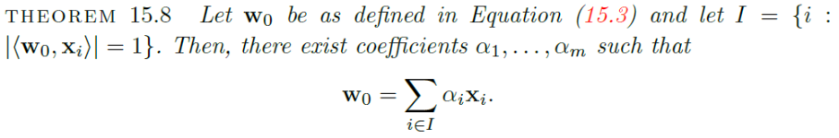
the SVM paradigm for learning halfspaces in high dimensional feature spaces: dim I <=m.

Hard SVM and Soft SVM
Imagine you have classmates (data points) belonging to different groups (classes), let's say red and blue. An SVM classifier draws a line (decision boundary) to separate the groups.
- Hard SVM: This is like having a strict teacher who wants a perfect separation. The line goes exactly between the closest red and blue classmate, creating a hard margin.
  - Problem: Real data might not be perfectly separable. A single classmate standing in the wrong place could mess up the whole line!
- Soft SVM: This is like having a more understanding teacher who allows some classmates to stand a little on the wrong side of the line. The margin can be a bit "softer" to accommodate these outliers.
  - Solution: Soft SVM allows some misclassifications but penalizes them. It creates a larger margin where possible, while still trying to keep most classmates on the right side of the line.
Here's a table summarizing the key differences:
Feature | Hard SVM | Soft SVM
Decision Boundary | Strict separation, no classmates allowed in between | Allows some classmates on the "wrong" side
Margin | Hard margin, maximized distance between classes | Softer margin, allows some misclassifications
Real-world applicability | May struggle with non-perfectly separable data | More flexible, handles non-separable data better

SVMs are popular for classification tasks due to several advantages:
- Effective Margin Maximization: SVMs aim to find the hyperplane that maximizes the margin between the data points of different classes. This margin represents the decision boundary and contributes to good generalization (performance on unseen data).
- High-Dimensional Mapping: SVMs can be combined with kernel methods to handle non-linear data. Kernel methods implicitly map the data points to a higher-dimensional space where they become linearly separable, allowing SVMs to effectively classify them.
- Robustness to Noise: SVMs can be less susceptible to noise in the data compared to some other algorithms because of the focus on maximizing the margin.
Multi-Class Classification with SVMs:
While SVMs are designed for binary classification, they can be extended to handle multi-class problems with several approaches:
1. One-vs-One:
- This is a common approach where you build multiple binary SVMs, one for each pair of classes. For example, with 10 classes, you would have 45 (10C2) binary classifiers, each separating one class from all others.
- During prediction, a new data point is classified by each SVM, and the class with the most "votes" from the winning binary classifiers becomes the predicted class.
2. One-vs-Rest:
- Here, you build one SVM classifier for each class. Each SVM separates its assigned class from all other classes combined.
- During prediction, a new data point is classified by each SVM, and the one with the highest output score is considered the predicted class.

SVM Classification with and without Kernels
1. Limitations of Linear SVM (without Kernels):
- Linear Separability Requirement: Data points must be almost linearly separable in the original feature space for effective classification. Soft-SVM can handle some misclassifications with a penalty term, but it won't work well if the data is highly non-linearly separable.
- Limited to Binary Classification: Linear SVM itself is inherently designed for binary classification problems (separating two classes). While there are workarounds for multi-class problems (like One-vs-Rest), they might not perform well on complex, non-linear datasets without kernels.

2. SVM with Kernels:
- Solvable Tasks:
  - Both linearly and non-linearly separable binary classification problems.
  - Multi-class classification problems using One-vs-One or One-vs-Rest approaches.
- Advantages:
  - Flexibility to handle non-linear data through implicit mapping to a higher-dimensional space.
  - Increased performance on non-linearly separable datasets.
  - More powerful and versatile compared to linear SVM.
3. Multi-Class Classification with SVMs:
- Kernel Methods: Both One-vs-One and One-vs-Rest can be used with SVM with kernels.
- Without Kernels: Only One-vs-Rest can be used with linear SVM, as One-vs-One requires pairwise comparisons, which are not feasible in a linear setting.
4. Class Separation in Multi-Class Classification:
- Hyperplanes: In both linear and kernel SVM, the separation of classes is achieved through hyperplanes, even for multi-class problems.
- Nonlinear Separators: Kernel SVM can use nonlinear decision boundaries by implicitly mapping the data to a higher-dimensional space where linear separation becomes possible.

Dimensionality of Separation:
- Linear SVM: The separation occurs in the original feature space (R^d).
- Kernel SVM: The separation occurs in a higher-dimensional space induced by the kernel function. The dimensionality can be infinite in some cases.
5. Role of Kernels in Kernel SVM:
- Kernels transform the data into a higher-dimensional space where linear separation becomes possible.
- Different kernels induce different mappings, leading to different decision boundaries in the higher-dimensional space.
- The choice of kernel affects the complexity of the model and its performance on the given dataset.
6. Evaluation Metrics for SVM Models:
- Accuracy, F1 Score, and other metrics: Applicable to all SVM models (with or without kernels) and provide overall performance measures.
- Confusion Matrix: Particularly useful for multi-class classification, providing a detailed breakdown of correct and incorrect classifications for each class.
Additional Considerations:
- Regularization techniques can be used to prevent overfitting in SVM models.
- Hyperparameter tuning is crucial for optimal performance of SVM models, involving the selection of parameters like C (regularization strength) and gamma (kernel parameter).
Summary:
SVM is a powerful machine learning algorithm for classification tasks. It can be used with or without kernels, with kernels providing the flexibility to handle non-linear data. Multi-class classification can be tackled with SVM using One-vs-One or One-vs-Rest approaches. The choice of SVM model and its parameters depends on the specific problem and dataset at hand.

VM Classification with and without Kernels
1. SVM without Kernels (Linear SVM):
- Solvable Tasks: Linearly separable binary classification problems.
- Limitations:
  - Data points must be linearly separable in the original feature space.
  - Cannot handle non-linearly separable data.
  - Less flexible compared to SVM with kernels.
2. SVM with Kernels:
- Solvable Tasks:
  - Both linearly and non-linearly separable binary classification problems.
  - Multi-class classification problems using One-vs-One or One-vs-Rest approaches.
- Advantages:
  - Flexibility to handle non-linear data through implicit mapping to a higher-dimensional space.
  - Increased performance on non-linearly separable datasets.
  - More powerful and versatile compared to linear SVM.
3. Multi-Class Classification with SVMs:
- Kernel Methods: Both One-vs-One and One-vs-Rest can be used with SVM with kernels.
- Without Kernels: Only One-vs-Rest can be used with linear SVM, as One-vs-One requires pairwise comparisons, which are not feasible in a linear setting.
4. Class Separation in Multi-Class Classification:
- Hyperplanes: In both linear and kernel SVM, the separation of classes is achieved through hyperplanes, even for multi-class problems.
- Nonlinear Separators: Kernel SVM can use nonlinear decision boundaries by implicitly mapping the data to a higher-dimensional space where linear separation becomes possible.
Dimensionality of Separation:
- Linear SVM: The separation occurs in the original feature space (R^d).
- Kernel SVM: The separation occurs in a higher-dimensional space induced by the kernel function. The dimensionality can be infinite in some cases.
5. Role of Kernels in Kernel SVM:
- Kernels transform the data into a higher-dimensional space where linear separation becomes possible.
- Different kernels induce different mappings, leading to different decision boundaries in the higher-dimensional space.
- The choice of kernel affects the complexity of the model and its performance on the given dataset.
6. Evaluation Metrics for SVM Models:
- Accuracy, F1 Score, and other metrics: Applicable to all SVM models (with or without kernels) and provide overall performance measures.
- Confusion Matrix: Particularly useful for multi-class classification, providing a detailed breakdown of correct and incorrect classifications for each class.
Additional Considerations:
- Regularization techniques can be used to prevent overfitting in SVM models.
- Hyperparameter tuning is crucial for optimal performance of SVM models, involving the selection of parameters like C (regularization strength) and gamma (kernel parameter).
Summary:
SVM is a powerful machine learning algorithm for classification tasks. It can be used with or without kernels, with kernels providing the flexibility to handle non-linear data. Multi-class classification can be tackled with SVM using One-vs-One or One-vs-Rest approaches. The choice of SVM model and its parameters depends on the specific problem and dataset at hand.

Limitations of Linear SVM (without Kernels):
- Linear Separability Requirement: Data points must be almost linearly separable in the original feature space for effective classification. Soft-SVM can handle some misclassifications with a penalty term, but it won't work well if the data is highly non-linearly separable.
- Limited to Binary Classification: Linear SVM itself is inherently designed for binary classification problems (separating two classes). While there are workarounds for multi-class problems (like One-vs-Rest), they might not perform well on complex, non-linear datasets without kernels.
Key Points:
- Soft-SVM with a cost parameter (C) allows for some misclassifications, making it more flexible than Hard-SVM, which requires perfect separation.
- However, even Soft-SVM has limitations when dealing with significantly non-linear data.
Linear SVM, even with Soft-SVM's flexibility, can struggle with highly non-linear data separations. That's where kernel methods come in to provide the power to handle such complexities.

Evaluation Metrics for SVM Models:
Applicable to All SVM Models (with or without Kernels):
- Accuracy: Measures the overall proportion of correctly classified data points.
- Precision: Measures the proportion of predicted positive cases that were actually correct.
- Recall: Measures the proportion of actual positive cases that were correctly classified.
- F1 Score: Combines precision and recall into a single metric.
- Other Metrics: ROC AUC, Log Loss, etc., can also be used depending on the specific problem and desired insights.
Confusion Matrix:
While the confusion matrix is highly valuable for multi-class classification, it's not limited to kernel SVMs. Here's the applicability:
- Multi-Class Classification: Particularly useful for understanding how well the model performs on each class in a multi-class setting (e.g., MNIST with 10 digits). It provides a breakdown of correct and incorrect classifications for each class.
- Binary Classification: Can also be used for binary classification problems (with or without kernels) to analyze the model's performance in terms of true positives, true negatives, false positives, and false negatives.
Additional Notes:
- Soft computing is a broader concept encompassing techniques like fuzzy logic and neural networks. It doesn't directly exclude the use of evaluation metrics. Soft-SVM can still leverage all the mentioned metrics for performance evaluation.
- While kernel methods are often used for complex, multi-class problems, they are not a strict requirement for using a confusion matrix. It's a valuable tool for any multi-class classification task, regardless of the specific SVM model (linear or kernel-based).
Summary:
Metrics like accuracy, precision, recall, F1 score, and others can be used to evaluate all SVM models (with or without kernels) for both binary and multi-class classification tasks. The confusion matrix is particularly insightful for multi-class problems, helping analyze the model's performance on each class. Kernel methods, while not a prerequisite for using these metrics, offer increased flexibility for handling non-linear data in classif

- Hard SVM: Aims for perfect separation of classes, resulting in either a clear classification or an error (data point falls on the wrong side of the hyperplane). You can still calculate metrics like accuracy by measuring the proportion of data points correctly classified on the "correct" side of the hyperplane.
- Soft SVM: Introduces a cost parameter (C) that allows for some misclassifications. This flexibility allows you to calculate precision, recall, and F1 score, as these metrics consider both correctly classified and misclassified data points.
Kernels vs. Evaluation Metrics:
The choice of kernel (linear or non-linear) affects the decision boundary and potentially the model's performance, but it doesn't prevent you from using evaluation metrics. These metrics are essential tools for assessing the model's effectiveness regardless of the underlying SVM variant or kernel used.
Confusion Matrix:
While the confusion matrix is particularly useful for multi-class classification, it's also applicable to both hard and soft SVM in binary classification. It provides a breakdown of true positives, true negatives, false positives, and false negatives, enabling the calculation of precision, recall, and other metrics.
Summary:
Precision, recall, F1 score, accuracy, and the confusion matrix are all valuable tools for evaluating the performance of any SVM model (hard, soft, with or without kernels) for both binary and multi-class classification problems. While soft SVM and kernels offer additional flexibility and capabilities, they are not prerequisites for using these evaluation metrics.

Clarification:
While Hard SVM aims for perfect separation, it doesn't necessarily fail if a few data points violate the separability assumption. Here's what happens:
- Perfect Separation: If the data is perfectly separable, Hard SVM finds a clear hyperplane with all points correctly classified on their respective sides. You can then calculate accuracy (proportion of correctly classified points) as usual.
- Imperfect Separation: If a few data points lie on the wrong side or close to the hyperplane in a non-separable case, Hard SVM technically fails to achieve its goal of perfect separation. However, it still attempts to find a "best fit" hyperplane that minimizes the overall margin violation caused by these misclassified points.
Evaluation Metrics for Hard SVM:
- In cases of imperfect separation, some data points might be classified incorrectly by the Hard SVM. This means metrics like accuracy will be lower than in the perfect separation case, reflecting the model's inability to perfectly classify all points.
- However, you can still calculate these metrics (accuracy, precision, recall, etc.) even for a Hard SVM with imperfect separation. They provide insights into the model's performance, even if it's not achieving perfect classification.
Soft SVM:
Soft SVM addresses the limitations of Hard SVM by allowing some misclassifications through a cost parameter (C). It can handle non-separable data by penalizing misclassifications, making it more robust and flexible. The evaluation metrics are fully applicable to Soft SVM as it inherently deals with some level of misclassification.
Summary:
- Hard SVM strives for perfect separation but can still provide evaluation metrics (though potentially lower accuracy) even with minor violations.
- Soft SVM is designed for more general cases and allows some misclassifications, making evaluation metrics like accuracy, precision, recall, etc., even more relevant for assessing its performance.
I apologize for the previous inconsistency in my explanations. The key takeaway is that you can use evaluation metrics for both Hard SVM and Soft SVM, but with slightly different interpretations based on their inherent capabilities.

Hard SVM Limitations:
- Complete Failure: Yes, there are scenarios where Hard SVM simply cannot classify the data and effectively "falls completely." This occurs when the data is inherently non-linearly separable, and no hyperplane can perfectly divide the classes in the original feature space. In such cases, Hard SVM will have no solution because its core principle is finding a perfect linear separation.
Soft SVM Advantages:
- Soft SVM to the Rescue: This is where Soft SVM shines. By introducing a cost parameter (C), it allows for some misclassifications and finds a "best-fit" hyperplane even with non-separable data. It penalizes misclassifications but prioritizes maximizing the margin as much as possible.
Soft SVM Limitations (But Less Prone to Failure):
- Soft SVM Limitations: While Soft SVM is more robust than Hard SVM, it's not foolproof. Here are some limitations:
  - Highly Imbalanced Datasets: If a dataset is extremely imbalanced (one class has significantly more data points than others), even Soft SVM can struggle. It might prioritize the majority class, leading to poor performance for the minority class. Techniques like data balancing or cost parameter adjustments can help mitigate this.
  - Very Noisy Data: If the data is heavily contaminated with noise or outliers, even Soft SVM might have difficulty finding a meaningful decision boundary. Preprocessing techniques like noise reduction might be necessary.
  - High-Dimensional Data with Irrelevant Features: In very high-dimensional spaces with many irrelevant features, Soft SVM can become computationally expensive and potentially overfit the data. Feature selection techniques can be helpful here.
Summary:
- Hard SVM can completely fail when data is non-linearly separable.
- Soft SVM is generally more robust but can still struggle with highly imbalanced data, noisy data, or high-dimensional data with irrelevant features.
In most practical scenarios, Soft SVM offers a more flexible and reliable approach to classification, especially when dealing with real-world datasets that might not be perfectly separable.

The choice between Soft-SVM and Kernel-SVM depends on the specific characteristics of your data and the classification problem you're trying to solve. Here's a breakdown to help you decide:
Soft SVM:
- Advantages:
  - Simpler to implement and train compared to Kernel-SVM.
  - Generally faster training times.
  - Less prone to overfitting than Kernel-SVM with high-dimensional kernel spaces.
- Disadvantages:
  - Limited to linearly separable data (although it can handle some non-separability with the cost parameter).
  - Might not capture complex non-linear relationships between features in the data.
- Recommended When:
  - The data is likely to be linearly separable or only slightly non-linear.
  - Interpretability of the model is important (Soft SVM decision boundaries are easier to interpret in the original feature space).
  - Computational efficiency is a concern.
Kernel SVM:
- Advantages:
  - Can handle complex non-linear data by implicitly mapping it to a higher-dimensional space.
  - Often leads to better performance on non-linearly separable datasets.
- Disadvantages:
  - More complex to implement and tune compared to Soft SVM.
  - Training times can be longer, especially with large datasets.
  - Decision boundaries can be less interpretable due to the mapping to a higher-dimensional space.
  - Prone to overfitting if the kernel hyperparameters are not chosen carefully.
- Recommended When:
  - The data is suspected to be non-linear.
  - Achieving high classification accuracy is the primary goal, even if interpretability is less important.
  - Computational resources are sufficient for potentially longer training times.
Real-World Case Studies:
- Start with Soft SVM: For real-world case studies, it's often a good practice to start with Soft SVM due to its simplicity and interpretability. If the performance is satisfactory, you might not need the additional complexity of Kernel-SVM.
- Consider Kernel SVM if Needed: If Soft SVM doesn't achieve the desired accuracy or you suspect non-linearity in the data, then explore Kernel-SVM. Experiment with different kernel functions (e.g., RBF, polynomial) and hyperparameter tuning to find the best configuration.
Additional Tips:
- Visualization techniques like scatter plots with class labels can help you get a sense of the data's linearity and potentially guide your choice between Soft SVM and Kernel-SVM.
- Consider using grid search or other hyperparameter tuning techniques to optimize the performance of both Soft SVM and Kernel-SVM for your specific dataset.
Ultimately, the best choice depends on the specific problem and data at hand. Experimenting with both approaches and evaluating their performance can help you determine the optimal solution for your real-world case study.

KERNAL:
A kernel is a type of a similarity measure between instances. The special property of kernel similarities is that they can be viewed as inner products in some Hilbert space (or Euclidean space of some high dimension) to which the instance space is virtually embedded.
The “kernel trick” enables computationally efficient implementation of learning, without explicitly handling the high dimensional representation of the domain instances.
Kernel based learning algorithms, and in particular kernel-SVM, are very useful and popular machine learning tools. Their success may be attributed both to being flexible for accommodating domain specific prior knowledge and to having a well developed set of efficient implementation algorithms.

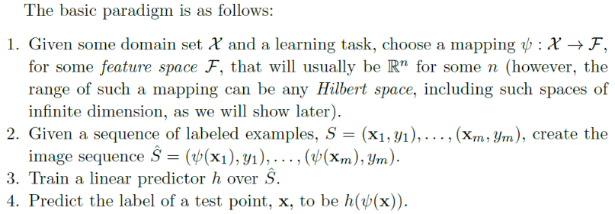
p.3: Often some generic mappings that enable to enrich the class of halfspaces and extend its expressiveness are used!
One notable example is polynomial mappings,

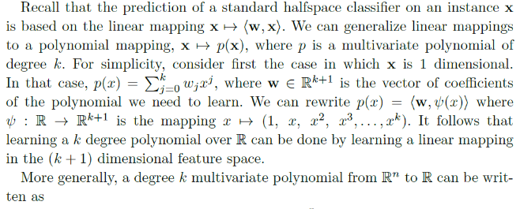
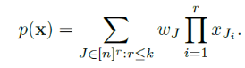
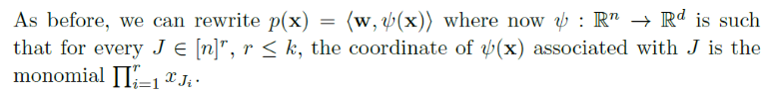

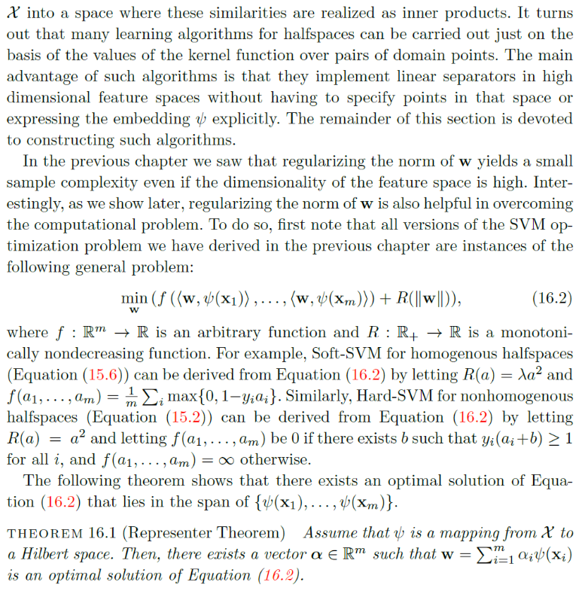

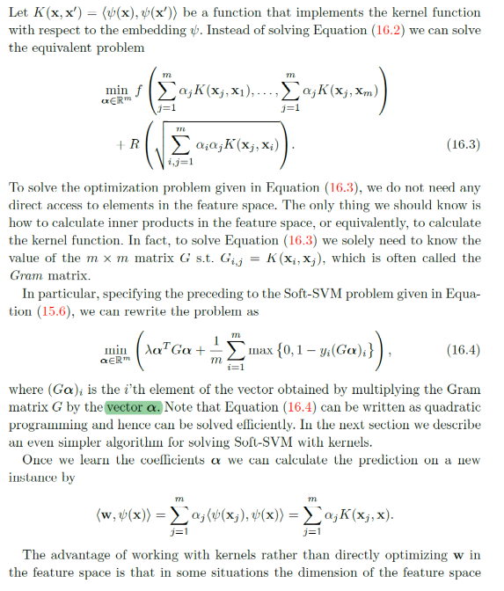
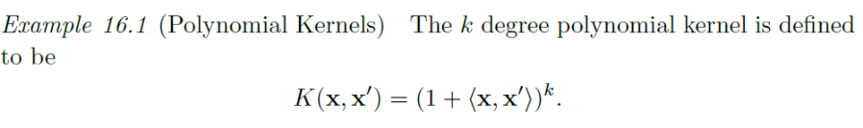

Gaussian Kernel
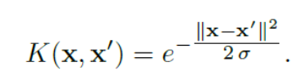
Implementing Soft-SVM with Kernels

SVM (Support Vector Machine) and Kernel Methods: briefly
1. SVM (Support Vector Machine):
SVMs are supervised learning algorithms used for classification tasks. They
aim to find a hyperplane in the feature space that best separates the data points belonging to different classes.
Here are the key ideas of SVM:
- Maximum Margin Hyperplane: The SVM seeks the hyperplane that maximizes the margin between the hyperplane and the closest data points of each class (called support vectors). This margin represents the decision boundary between the classes.
- High-Dimensional Feature Space: SVMs can be applied to non-linearly separable data by projecting them into a higher-dimensional space using kernel functions. (This will be discussed further in section 2)
- Hard vs. Soft Margin:
  - Hard Margin: Ideally, the hyperplane perfectly separates the data points. However, real-world data might not be perfectly separable.
  - Soft Margin (Soft-SVM): Soft-SVM allows for some data points to lie on the wrong side of the margin with a penalty term added to the objective function to control the trade-off between maximizing the margin and allowing some misclassifications.
2. Kernel Methods:
Kernel methods are a powerful technique that allows SVMs (and other algorithms) to handle non-linear data.
Here's the core idea:
- Non-linear Feature Space: Kernel methods implicitly map the data points from the original input space to a higher-dimensional feature space where they become linearly separable.
- Kernel Function: We don't explicitly compute this high-dimensional space. Instead, we use a kernel function that operates on the original data points and calculates the inner product (dot product) in the high-dimensional space. This avoids the computational cost of explicit mapping.
- Common Kernel Functions: Examples include linear kernel, polynomial kernel, and RBF (Radial Basis Function) kernel. Each kernel function induces a different mapping to the feature space.
3. Implementing Soft-SVM with Kernels:
Here's a high-level overview of implementing a Soft-SVM with kernels:
- Choose a kernel function: Select a kernel function based on your data and the type of non-linearity you expect.
- Define the cost parameter (C): This parameter controls the trade-off between maximizing the margin and allowing misclassifications in Soft-SVM.
- Train the model: Use an optimization algorithm to find the optimal hyperplane parameters in the high-dimensional feature space (implicitly through the kernel function).
- Classification: Once trained, the model can classify new data points by mapping them to the high-dimensional space (using the kernel) and calculating their distance from the hyperplane.
4. Parameters used within these methods:
- SVM:
  - Cost parameter (C): Controls the trade-off between margin and misclassifications (Soft-SVM)
- Kernel Methods:
  - Kernel function: Defines the mapping to the high-dimensional feature space (e.g., linear kernel, polynomial kernel, RBF kernel)
- Additional parameters: Some kernel functions might have additional hyperparameters that need to be tuned (e.g., degree for polynomial kernel, gamma for RBF kernel)

Py Functions for SVM - Kernel
import numpy as np
from sklearn import datasets
from sklearn.model_selection import train_test_split
from sklearn.svm import SVC
from sklearn.metrics import accuracy_score

# Load a dataset (let's use the famous Iris dataset for illustration)
iris = datasets.load_iris()
X = iris.data
y = iris.target

# Split the data into training and testing sets
X_train, X_test, y_train, y_test = train_test_split(X, y, test_size=0.2, random_state=42)

# Create an SVM classifier with a radial basis function (RBF) kernel
svm_classifier = SVC(kernel='rbf', C=1.0, gamma='scale')
# kernel: Specifies the kernel type. 'rbf' stands for Radial Basis Function (RBF) kernel.
# C: Regularization parameter. Controls the trade-off between smooth decision boundary and classifying training points correctly.
# gamma: Kernel coefficient. It defines how far the influence of a single training example reaches.

# Train the classifier
svm_classifier.fit(X_train, y_train)

# Make predictions on the test set
y_pred = svm_classifier.predict(X_test)

# Evaluate the accuracy of the model
accuracy = accuracy_score(y_test, y_pred)
print(f"Accuracy: {accuracy}")
Below is an example of Python code for SVM using scikit-learn with explanations of key functions and parameters:
import numpy as np
from sklearn import datasets
from sklearn.model_selection import train_test_split
from sklearn.svm import SVC
from sklearn.metrics import accuracy_score

# Load a dataset (let's use the famous Iris dataset for illustration)
iris = datasets.load_iris()
X = iris.data
y = iris.target

# Split the data into training and testing sets
X_train, X_test, y_train, y_test = train_test_split(X, y, test_size=0.2, random_state=42)

# Create an SVM classifier with a radial basis function (RBF) kernel
svm_classifier = SVC(kernel='rbf', C=1.0, gamma='scale')
# kernel: Specifies the kernel type. 'rbf' stands for Radial Basis Function (RBF) kernel.
# C: Regularization parameter. Controls the trade-off between smooth decision boundary and classifying training points correctly.
# gamma: Kernel coefficient. It defines how far the influence of a single training example reaches.

# Train the classifier
svm_classifier.fit(X_train, y_train)

# Make predictions on the test set
y_pred = svm_classifier.predict(X_test)

# Evaluate the accuracy of the model
accuracy = accuracy_score(y_test, y_pred)
print(f"Accuracy: {accuracy}")

Explanation:
- Loading Data: We load the Iris dataset, a commonly used dataset in machine learning.
- Splitting Data: The data is split into training and testing sets using train_test_split.
- Creating SVM Classifier: We create an SVM Classifier (SVC) with an RBF kernel. The kernel parameter is set to 'rbf', and other important parameters include C for regularization and gamma for the RBF kernel.
- Training: The classifier is trained on the training data using the fit method.
- Prediction: Predictions are made on the test set using the predict method.
- Evaluation: The accuracy of the model is evaluated using accuracy_score.
Feel free to experiment with different kernels ('linear', 'poly', etc.) and tune the parameters based on your specific dataset and problem. The choice of kernel and parameter values often involves some trial and error. If you have further questions or need additional clarification, please let me know!

from sklearn import svm
classifier = svm.SVC(C=1, gamma=0.001)

The provided code snippet from sklearn import svm;
classifier = svm.SVC(C=1, gamma=0.001)
uses the Radial Basis Function (RBF) kernel by default for the SVM classifier.
from sklearn import svm #Imports the SVC class for Support Vector Classification from scikit-learn's svm module.
classifier = svm.SVC(C=1, gamma=0.001) # Creates an SVC object, which is the SVM classifier.
C=1: Sets the cost parameter for the Soft-SVM. In this case, it's set to the default value of 1.0.
gamma=0.001: Sets the gamma parameter. Since no kernel function is explicitly specified, and gamma is provided, scikit-learn assumes you're using the RBF kernel and sets it with this value.

Understanding Kernel Selection in scikit-learn's SVC:
The SVC class in scikit-learn uses the linear kernel as the default (kernel='linear') if no kernel function is specified.
However, when you provide the gamma parameter, scikit-learn interprets it as an indication that you intend to use the RBF kernel. This is because gamma is a specific parameter associated with the RBF kernel.
Alternative Kernel Selection:
#If you want to explicitly use a different kernel function, you can specify it in the SVC constructor:
classifier = svm.SVC(C=1, gamma=0.001, kernel='poly') # Example using polynomial kernel

After SVC implementation:
Precision:
- Precision represents the ratio of correctly predicted positive cases (belonging to the positive class) out of all the cases the model predicted as positive.
- In simpler terms, it answers the question: "Of all the data points the model labeled as positive, how many were actually positive?"
Recall:
- Recall represents the ratio of correctly predicted positive cases out of all the actual positive cases in the dataset.
- It answers the question: "Of all the actual positive cases in the data, how many did the model correctly predict as positive?"
F1-Score:
- F1-score is a harmonic mean between precision and recall, combining both metrics into a single score. It provides a balanced view of the model's performance, considering both its ability to identify true positives and avoid false positives.
- A higher F1-score indicates better overall performance.
Support:
- Support refers to the total number of data points belonging to a particular class in the test dataset. It provides context for interpreting the other metrics.
Example:
Let's say your classification task involves predicting whether an email is spam (positive class) or not spam (negative class). Here's how the metrics might be interpreted:
- Precision: If the precision for the spam class is 0.8, it means that out of every 10 emails the model classified as spam, 8 were actually spam emails.
- Recall: If the recall for the spam class is 0.7, it means that out of all the actual spam emails in the test dataset, the model correctly identified 70% of them.
- F1-Score: A high F1-score (close to 1) for the spam class would indicate that the model is good at correctly identifying spam emails while avoiding a significant number of false positives (non-spam emails incorrectly classified as spam).
Overall, the classification report helps you evaluate how well your SVC model is generalizing to unseen data and identifying patterns in your specific classification task.

Breakdown of the Report:
- "Classification report for classifier SVC(C=1, gamma=0.001):" This line displays the classifier type you used (SVC with specific parameters)
- The table:
  - "precision": This column shows the precision for each digit class (0-9). It represents the proportion of predicted positive cases (classified as that digit) that were actually correct for that class.
  - "recall": This column shows the recall for each digit class. It represents the proportion of actual positive cases (actual digits) that were correctly classified by the model.
  - "f1-score": This column displays the F1-score for each digit class. It's a harmonic mean between precision and recall, providing a balanced view of performance.
  - "support": This column shows the total number of data points belonging to each digit class in the test set (context for interpreting other metrics).
- "accuracy": This line shows the overall accuracy of the classifier on the test set, which is the proportion of correctly classified data points.
3. Interpretation in context of MNIST:
- High precision and recall values (close to 1) across all digit classes indicate that the model is performing well. It's correctly identifying most of the digits and avoiding many false positives/negatives.
- The overall accuracy close to 0.97 signifies that the model is accurately classifying nearly 97% of the digits in the test set.
4. Additional Considerations:
- While this report provides valuable insights, it's just one metric. Consider using other evaluation metrics (e.g., confusion matrix) to get a more comprehensive understanding of the model's performance.
- You might want to experiment with different hyperparameters (C and gamma) for the SVC to see if you can improve the model's performance.

Overall, the classification report suggests that your SVM classifier with the chosen parameters is performing well on the MNIST dataset

2) the output you provided is a Confusion Matrix generated by metrics.confusion_matrix in scikit-learn. It provides a detailed breakdown of how your SVM classifier performed on the MNIST test set for classifying handwritten digits (0-9).
Structure:
- The confusion matrix is a 2D array with rows and columns representing the actual digit classes (0-9) in the test set.
- Each element confusion_matrix[i, j] represents the number of data points that were:
  - Predicted as class j: This corresponds to the column index (j).
  - But actually belonged to class i: This corresponds to the row index (i).
Example:
- Looking at confusion_matrix[1, 1] = 210, it means that 210 images from the actual digit class 1 (second row) were correctly classified as digit 1 (first column).
- Conversely, confusion_matrix[3, 0] = 0 indicates that no images from the actual digit class 3 (fourth row) were mistakenly classified as digit 0 (first column).
Understanding Performance:
- Ideally, most values should be concentrated on the diagonal. This signifies that the model correctly classified most digits.
- Off-diagonal elements represent misclassifications. A higher value at confusion_matrix[i, j] (where i != j) indicates that the model frequently confused digit class i with digit class j.
MNIST Specific Analysis:
Looking at your confusion matrix, we can observe the following:
- High diagonal values: Most digits were correctly classified, suggesting good overall performance.
- Some off-diagonal elements: There are some misclassifications, but not a significant number. Here are some potential observations:
  - confusion_matrix[2, 4] = 4: Some images of digit 2 might be confused with digit 4.
  - confusion_matrix[4, 8] = 8: There might be some confusion between digits 4 and 8.
  - You can analyze other off-diagonal elements to identify similar patterns.
Overall, the confusion matrix reinforces the positive impression from the classification report. The model is performing well, but there's still room for improvement by potentially adjusting hyperparameters or exploring different classification algorithms.
Additional Tips:
- You can visualize the confusion matrix as a heatmap to see the distribution of values more clearly. This can help identify patterns in misclassifications.
- Consider using other evaluation metrics alongside the confusion matrix for a more comprehensive understanding of the model's performance.

